Description: We have all felt the ups and downs of our emotions during the pandemic. Music can be a positive coping tool to overcome intense emotions like anger, fear, and grief. Families will play the provided card game to share songs and create music together.

Time: 20-30 minutes

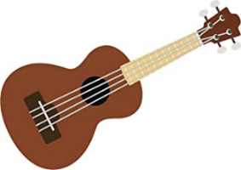
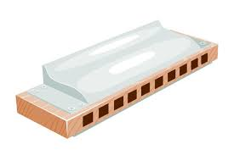
Materials:
- Electronic device (phone, computer) that can play music
- Provided prompt cards
- Scissors
- Instrument (if you own one), optional
- Toy instruments
- Household items such as a notebook, pots, pans, lids, pens or pencils, etc.
- Bowl or bag, plastic is fine

Directions:
- Cut the prompt cards with scissors and place in a bowl or a plastic bag. Gather everyone in one area, with the cards in the center.
  - Each card contains two prompts, one on each side.
- All players will select a random card from the bowl/bag. Don’t read the card out loud yet!
- One by one, players will read the BLUE side out loud. Each player will then find an object in their house that resembles the instrument written on their own card. Use the hints and work together!
  - If you own the instrument described, you can use it!
- Once everyone finds an instrument or object, they will read the RED side of their card. Each player will then choose a song they listen to when they feel the emotion listed on their own card.
- One at a time, players will find the song on a device (phone, computer) and play it for the rest of the family. As the song plays, every family member will use their instrument to play along with the song.
  - Players can sing along if they know the lyrics!
- Continue until each player has had a turn to play their song. Feel free to switch instruments to make things interesting, or create your own song as a family - have fun!

SAD | JOYFUL
FRUSTRATED | OVERWHELMED
PEACEFUL | LONELY
FEARFUL | HOPEFUL
EXCITED | NERVOUS

BLOWN BOTTLE  Hint: Find a plastic or glass bottle and blow over the bottle opening. | TRUMPET  Hint: Use the toy horn from the box.
KAZOO  Hint: Use the toy kazoo from the box. | SYMBOL  Hint: Use two metal lids from kitchen pots and pans.
GUIRO  Hint: Slide a pen or pencil along a comb or the ringed part of a notebook. | HARMONICA  Hint: Use the harmonica from the box.
BELLS  Hint: Use house or car keys. | MARACAS  Hint: Use the toy maraca from the box or add uncooked rice to an empty water bottle.
DRUM  Hint: Use a book and two pens/pencils. | GUITAR  Hint: Make a guitar with an empty Kleenex box and 5-6 rubber bands.

