My Heart Map

Description: What makes your heart happy? Families will talk about moments where they felt sad, angry, and happy using the emoji cards. Family members will design their own heart map and write or draw different things that make them happy.

Time: 30-45 minutes

Materials:
- Blank heart map worksheet, one per person
- Coloring supplies: colored pencils, crayons, and/or markers
- Emoji cards

Directions:
- Emotions are more complicated than just happy, sad, or mad! Place the emoji cards in the center of a table or the middle of where you are all seated together.
- Ask the questions below, one at a time. Everyone will answer by finding the emoji card that best represents the emotion and hold it up for all to see:
  - Which emoji describes the feeling you have…
    - When you wake up?
    - During school or work?
    - When you are with your family and friends?
    - Right now?
  - Which emoji have you felt the most during the COVID-19 pandemic?
- Then, take turns answering the following questions:
  - What does happiness mean to you?
  - Who or what makes you happy? Why?
- Pass out the heart map worksheets, one for each person.
- Write or draw things that make your heart happy in each section of the heart map with the provided crayons, colored pencils, and markers. Use the example on the following page for inspiration.
- Once everyone is finished, take turns sharing your heart maps and explain each section.

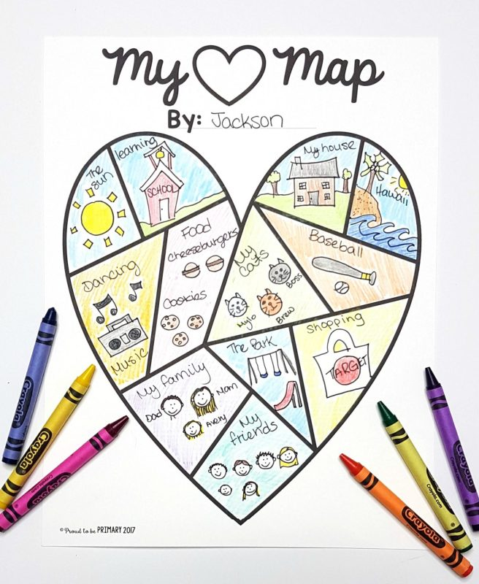
Example:

