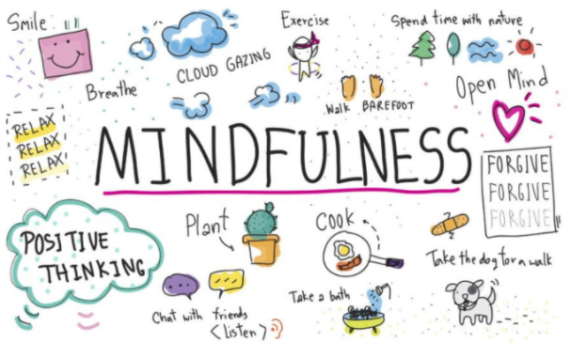
Mindfulness Activities

Safari Walk
Go on an adventure outside and use the checklist to notice as many plants, animals, and bugs as you can!
Rainbow Walk
Go on a walk and draw or write what you see in each color.

Music of the Decade
Listen to music of the decade you were born and see how many different instruments you can hear.

Mindful Snack
Eat a snack and describe the smell, texture, and taste of the food.

Mindful Touch
Choose objects in the household, then compare the difference in how they feel (dry vs. wet or soft vs. hard).
Mindful Pose
Go somewhere quiet and familiar and strike a power pose:
The Superman: Stand with your feet just wider than your hips, fists clenched, and arms reaching out to the sky, stretching your body as tall as possible.
The Wonder Woman: Stand tall with your legs wider than hip-width apart and hands or fists placed on the hips. Put your shoulders back and look straight ahead.
Body scan
Lie down on your back on a comfortable surface and close your eyes. Squeeze every muscle in your body as tight as you can by squishing your toes and feet, squeeze your hands into fists, and make your legs and arms as hard as stone. After 5 seconds, release all your muscles and relax for 60 seconds. Think about how your body is feeling throughout the activity.

Heartbeat
Start the activity by jumping up and down in place or doing jumping jacks for 60 seconds. When you have finished, sit down, and put a hand over your heart and close your eyes. Pay attention only to your heartbeat and breath.

