Exercise Time!
Video Link: https://youtu.be/ZzDSvlhSApU

Activity: Family members will take turns timing each other as they do each of the exercises. Time will stop once all exercises have been completed and the family member with the lowest time wins. *Exercises can be modified for safety*

Time: 3-10 minutes per family member

Materials:
- Exercise Time! Movement Activities handout (Page 2)
- Watch, clock, or electronic device with stopwatch application
- Jump rope
- Open space for exercise, inside or outside
- Comfortable shoes to jump, such as tennis shoes

Steps:
- Discuss as a family: How much movement do you think you have been getting since the pandemic started? For kids: Is it the same or different from when you were in school?
- Explain that with only 10 minutes of exercise a day, we can get the body and brain more alert and active. This can help between online classes or after a long day at school.
- Do a few stretches to warm up your muscles. Stretches can prevent injuries.
  - Do NOT try these exercises if you have an injury or heart condition. In this case, consult a doctor or health care professional before starting a new exercise routine.
  - Start with a few exercises, like the arm circles or toe touches, in the beginning.
- Pick a family member and get the stopwatch ready to keep track of time.
- One person in the family starts the first exercise (10 jumping jacks) and timer starts. Family members can do the exercises in the order they want, but all must be completed before the timer stops.
- Once the family member finishes all of the exercises, stop the stopwatch/timer. Record their time at the end of this page. Pick another family member and start again.
- Once all family members are done, the person with the lowest time wins!
- This activity can be done as many times a week as you want, and you can use it to see if you are improving your time each week. These movement activities can help get us up and moving in a competitive and fun way, especially with all the changes caused by the pandemic. Enjoy!

Family Member 1 Time: _______________
Family Member 2 Time: _______________
Family Member 3 Time: _______________
Family Member 4 Time: _______________
Family Member 5 Time: _______________
Family Member 6 Time: _______________
Family Member 7 Time: _______________
Family Member 8 Time: _______________
Exercise Time! Movement Activities

10 jumping jacks | 5 push ups  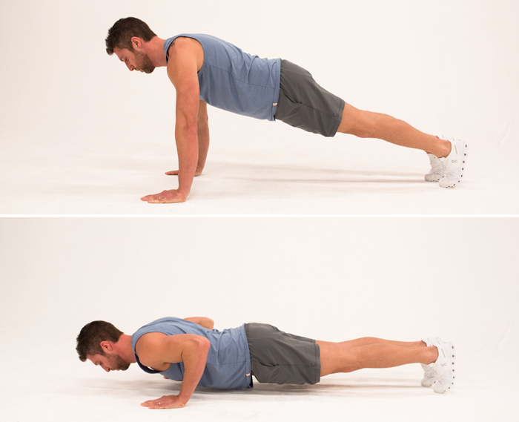 | 10 jumps with jump rope
Arms in circles clockwise  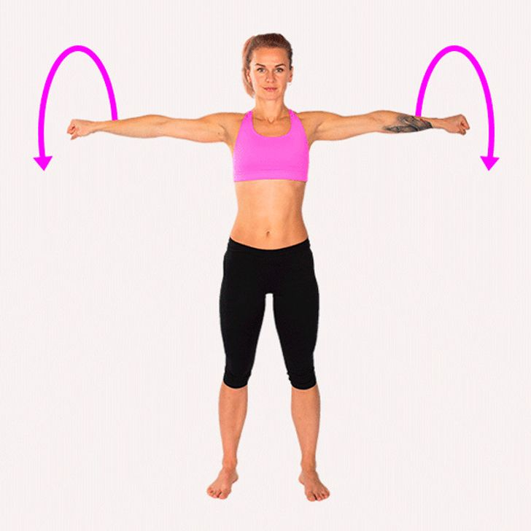 | 10 jumps on left foot  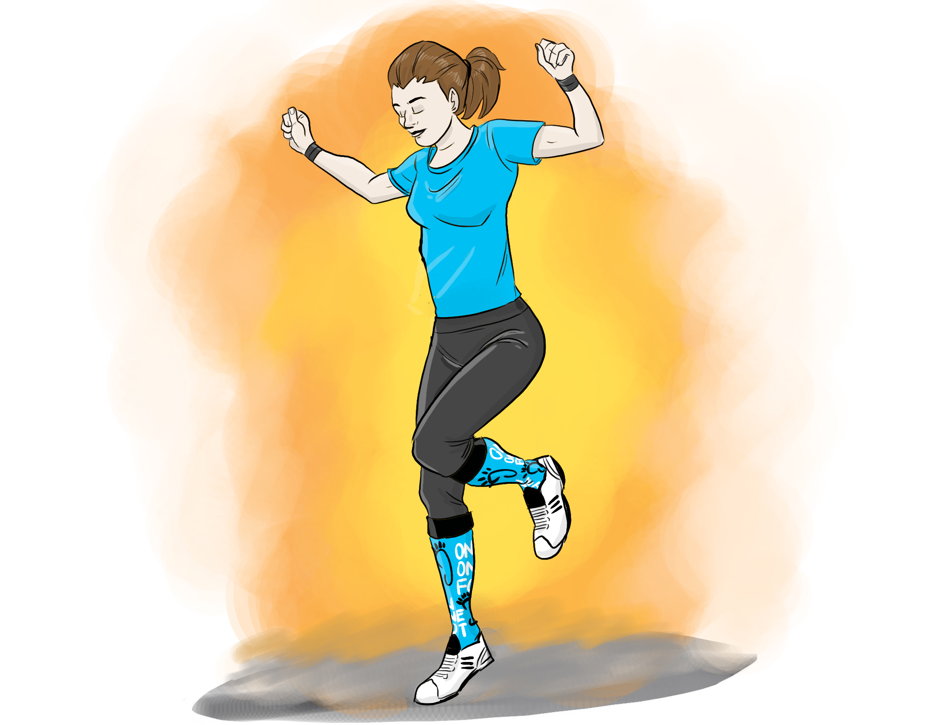 | 5 sit ups  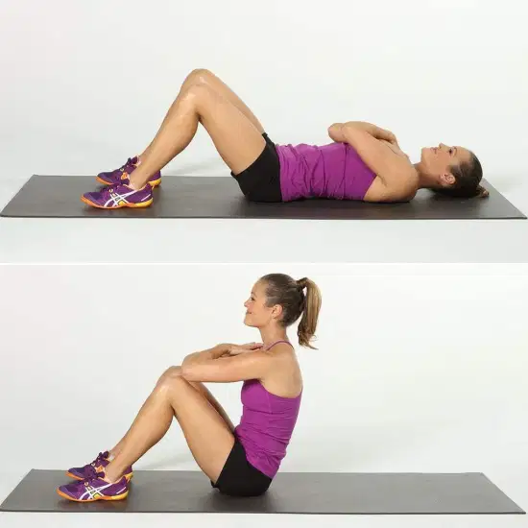
10 jumps on right foot | 10 jumps in jump rope on one foot  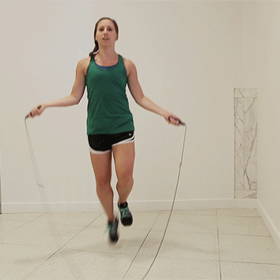 | Arms in circles counterclockwise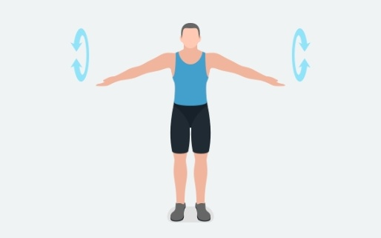
3 burpees  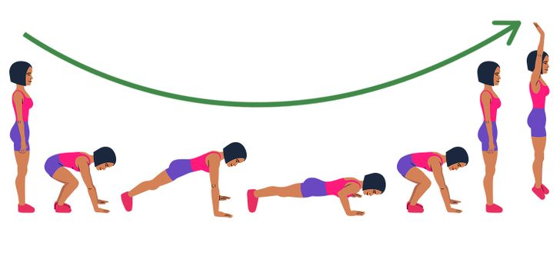 | 5 lunges  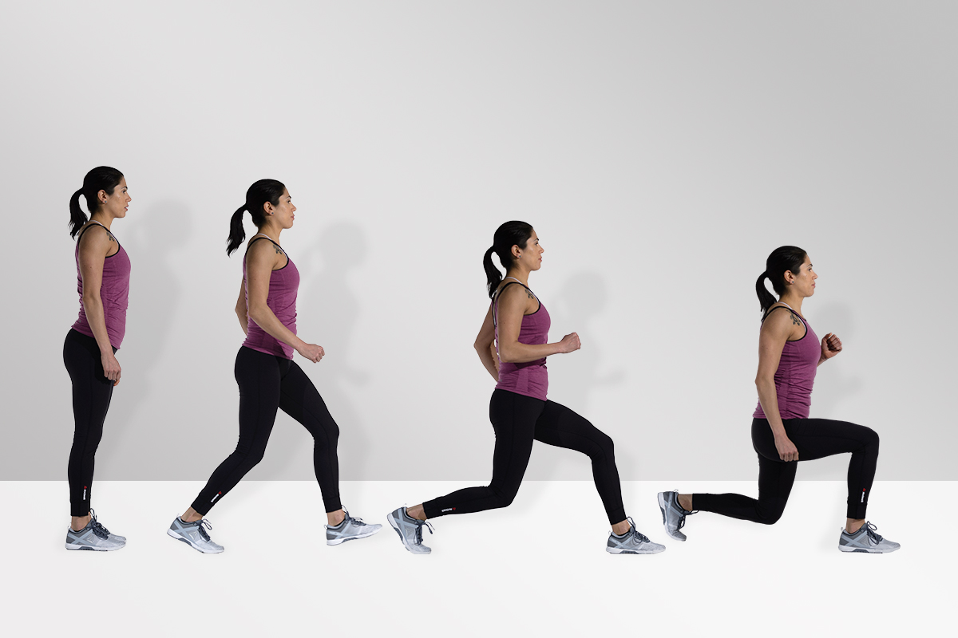 | 5 toe touches  