Design Your Very Own COVID-19 Face Mask
Video Link: https://youtu.be/X5cY0aRUCNI
Activity: We will learn why it is important for everyone to wear a mask to stop the spread of COVID-19. Wearing a mask is important for our health and can be a fun way to be creative! Let’s make masks that we enjoy wearing and are fun to show our family and friends. We will also learn how to wear our mask properly and wash it to keep us healthy and safe.
Time: 30 minutes – 60 minutes
Materials:
- Plain white or light-colored face mask
- Fabric markers
- Dawn dish detergent or laundry soap
Steps:
- Read the information on why it is important to wear a mask:
  - Scientists know that COVID-19 germs can live in the air we breathe.
  - It is important to wear masks to help block COVID-19 germs.
  - Masks allow us to breath safely in public spaces where COVID-19 germs may be in the air.
  - Masks help us stay healthy and protect ourselves, our families, our friends, and our communities from COVID-19!
- Optional: Watch the video to learn why wearing a mask is important: kidshealth.org/en/kids/face-masks.html
- Review the guidelines for how to wear and use your mask safely on Page 2 and 3.
- Select a mask that is comfortable from the box and try it on. Make sure it covers your nose and your mouth.
- Use fabric markers to create a fun mask. Try to draw a design on a piece of paper first. Look at some of our attached designs (Page 4) for inspiration! When you know what you want to put on your mask, draw it with the fabric pens on your mask.
- After you’ve decorated your mask, give it time to dry.
- Wash your mask before wearing.
  - You can wash your mask, using warm, soapy water. Scrub the mask for at least 20 seconds and dry them in direct sunlight.
    - You can wash your mask with your regular laundry: Use regular laundry detergent and the warmest appropriate water setting for the cloth used to make the mask.
    - Store clean masks in a clean place when you are not using them.
    - It is recommended that you wash your mask after every use.

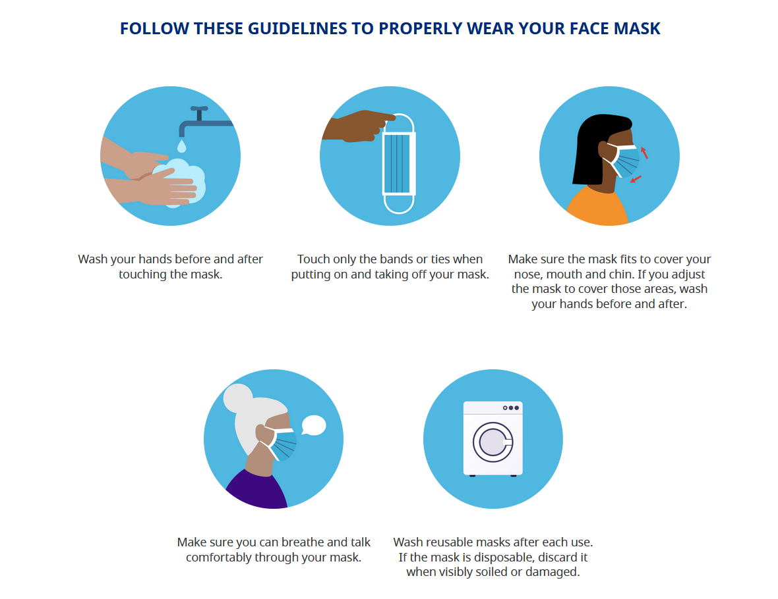
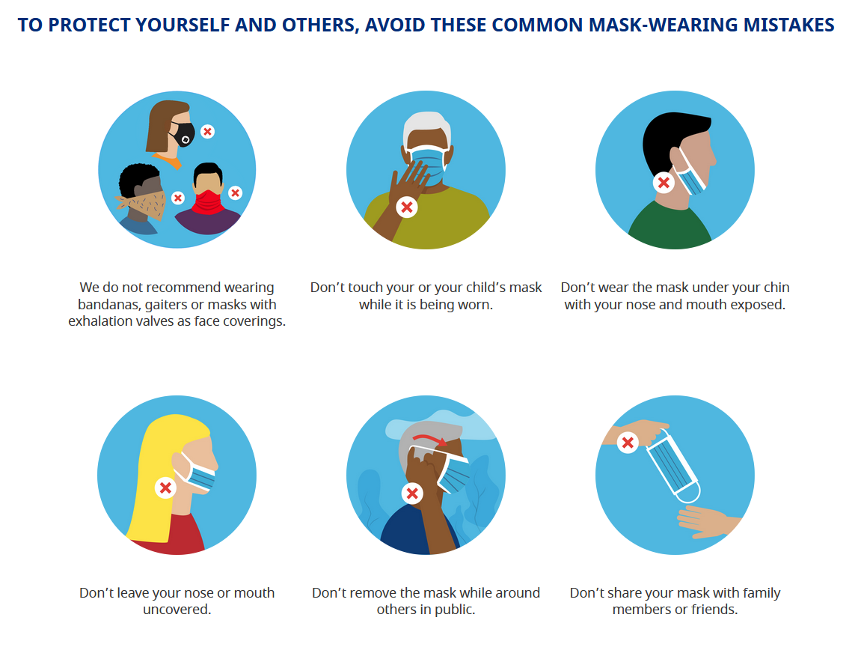
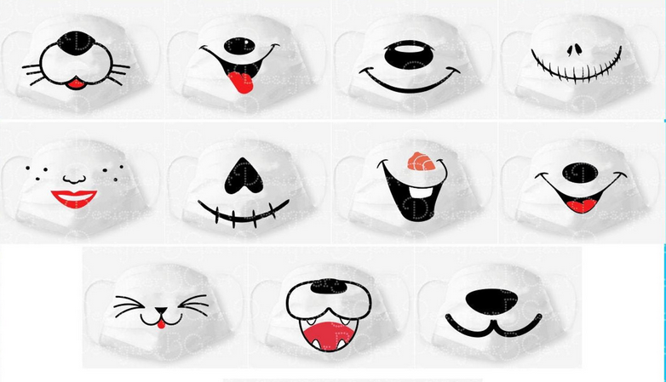
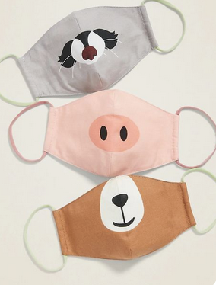
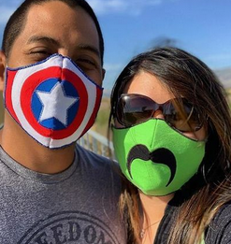
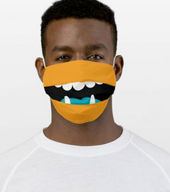
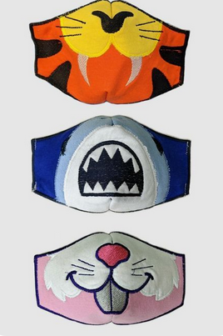
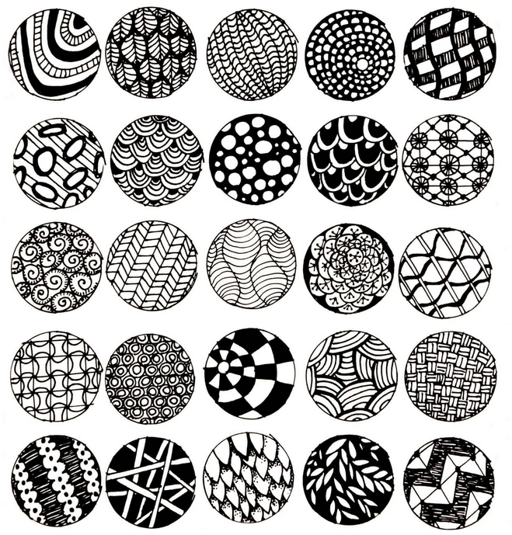
Decorating Ideas:
- Animals and Characters:

- Patterns:

