Delicious Smoky Chickpeas with Eggs and Bread
(Healthy Soda recipe included)
Video Link: https://youtu.be/4rE_KJvZ4Pw
Activity summary:
In this activity, families will review how to read the new Nutrition Labels, review handwashing steps, and make a healthy, balanced meal that keeps them full.

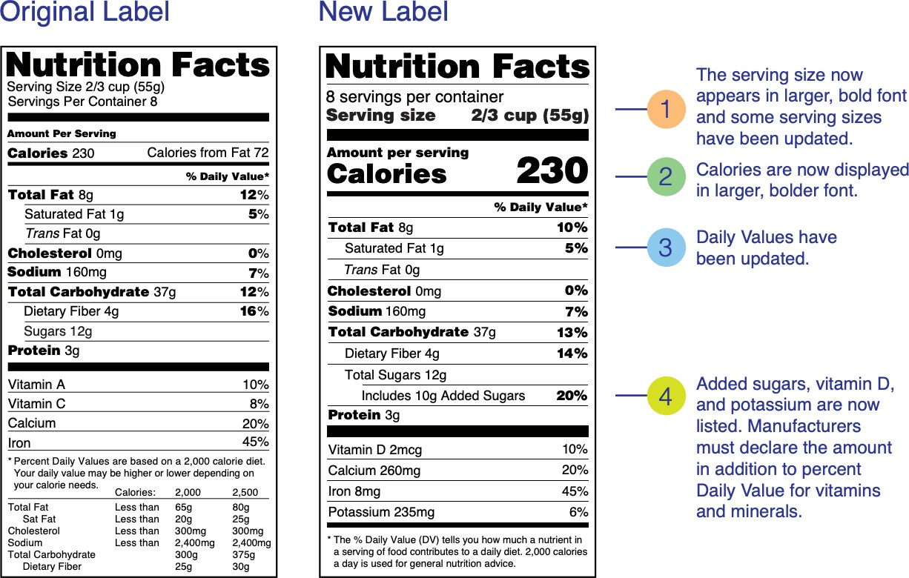
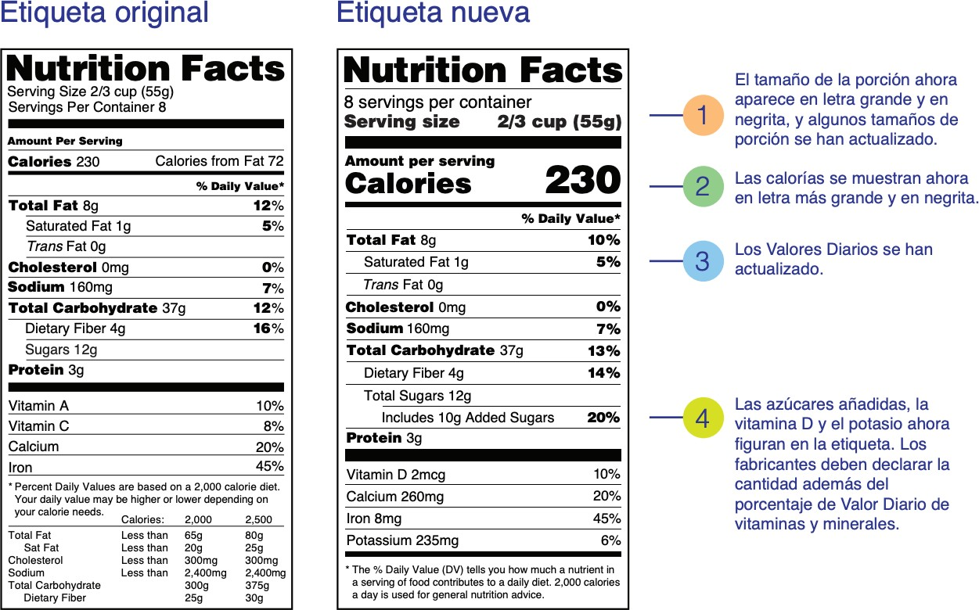
Handouts:

Figure 1. “What’s New with the Nutrition Facts Label” (US FDA)

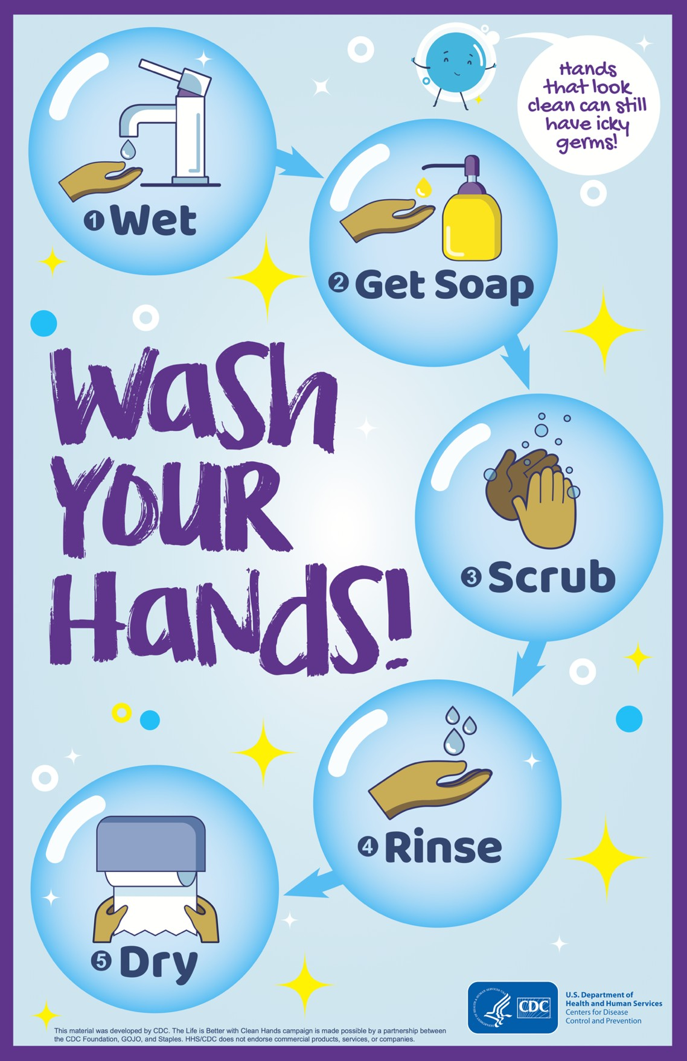
Figure 2. “Wash Your Hands Fact Sheet" (CDC)

Nutrition:

Delicious Smoky Chickpeas with Eggs and Bread
(Healthy Soda recipe included)

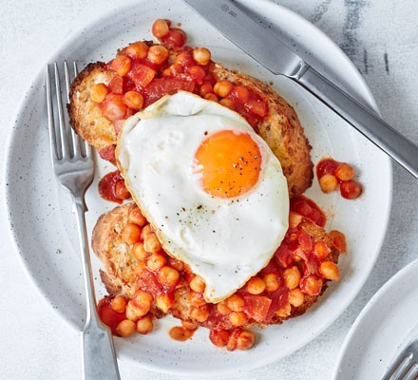
per serving for the meal ONLY

Calories | Fiber | Protein
~ 400 | 9g | 22g

Time:
10 – 15 minutes

Instructions:
- Start with reviewing the CDC’s Wash Your Hands Fact Sheet (page 2)
- Now, wash your hands for at least twenty seconds.
- Next, review the What’s New with the Nutrition Facts Label (page 1)
  - What is written in bold?
  - How are the new labels different from the old ones?
  - Can you name three differences?

Materials:
- Kitchenware
- Clean, washed hands
- A pitcher
- Forks
- Plates
- Frying pan

- Spoon (for mixing/stirring)
- Small Cups
- Knife and cutting board/large plate
- Bowl
- Toaster, optional

- Ingredients: (from BBC GoodFood Website), Makes 3-4 servings
- One bottle of a 100% juice
- One liter of unsweetened sparkling/carbonated water
- 1 tsp olive oil or vegetable oil, plus a drizzle
- ½ small red onion, chopped
- Salt & pepper

Let us take a moment to think about:
- 2-4 tsp of tomato paste (mixed in a ¼ cup of water)
- One can of chickpeas (about 15 oz), drained
- 2 tsp honey
- 2 tsp of vinegar
- 2-4 slices of whole wheat bread
- 2-4 eggs

- Look at Nutrition Facts Labels on the ingredients; how the food items are different or similar?

STEPS:
- Add half of the sparkling water and half the 100% juice into the pitcher.
- Make sure to stir for a couple of seconds. Now you have healthy soda!
- Refrigerate the healthy soda until you finish making the food (you can add ice cubes if you want)
- Now, heat ½ tsp of the oil in a pan.
- Tip in the chopped onion and cook until soft, 5-8 mins.
- Add chickpeas, tomato paste, honey and vinegar.
- Season with salt and pepper and bubble for 5 mins. Taste and add more seasoning, vinegar, or honey to your liking.
- Toast the bread in a new pan or using a toaster. Add to a plate.
- Heat the remaining oil in a frying pan and fry the eggs.
- Drizzle the toast with a little oil.
- Top each piece of toast with the chickpeas and a fried egg.
- Serve the healthy soda in the small cups.

Discussion (during the meal):
Discuss foods and how to stay healthy. Some discussion questions can include:
  - How are these ingredients considered healthy? Refer to “What's New with the Nutrition Facts Label.”
  - What other meals can you make from the ingredients?
  - What foods will you buy next time you go shopping? Refer to “What's New with the Nutrition Facts Label.”
  - What else can you add that is missing from your plate?

