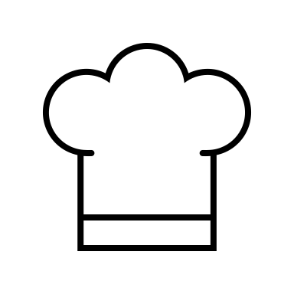
Chef for a Meal

Description: Congrats! The kids get to be the chef for this activity. Adults, you will be the sous (soo) chef, so your job is to make sure they are a safe chef! So, put on a white shirt or apron with your children and get ready to cook!

As the chef, your children will:
- Review the recipe.
- Check the food order from the Healthy 2B Me Box and place the ingredients into the correct MyPlate food groups of Protein, Fruit, Vegetable, Grain and Dairy.
  - The recipe will have 5 ingredients from each MyPlate food group.
- Watch the cooking demonstration:
- Cook this healthy MyPlate recipe and consider how your family designs regular meals!

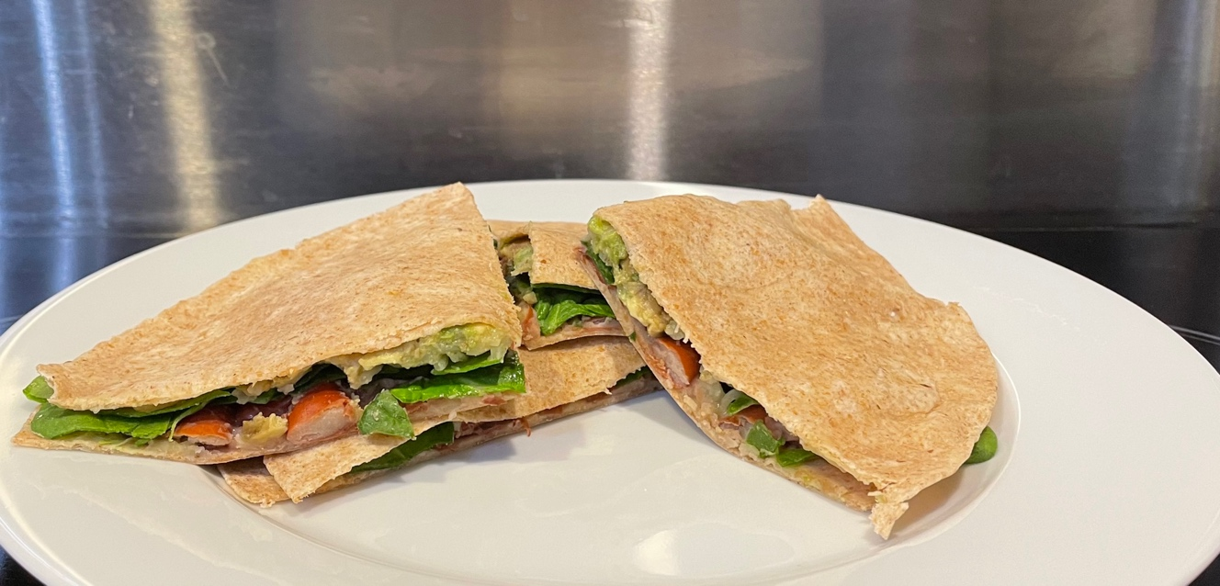

Food Order

Here is your list so you can check if you have one of each ingredient. You will need to find which ingredient fits into each MyPlate food group (Protein, Fruit, Vegetable, Grain and Dairy). There will be one ingredient for each group. Read the categories below to figure out which group each ingredient* belongs to.

*Hint: An ingredient can be in two groups. First find all ingredients that are only in one group, then see what groups are left!

MyPlate Food Groups:
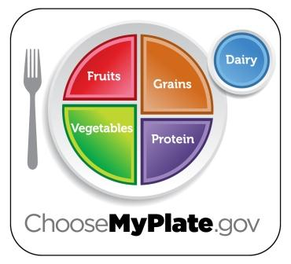
Protein - Can come from animal sources such as seafood, beef, pork, goat, poultry, and eggs or can come from plant sources such as beans, peas, lentils, nuts, seeds, and soy products. Beans, peas, and lentils are also part of the Vegetable Group.

Fruit - To be a fruit it would have 1 or more seeds and grow off the body of a plant. Is commonly known to be sweet BUT can be savory.

Vegetable - Includes all edible parts of a plant except the fruit. Some plants grow fruit, some don’t.

Grain - The seeds of wheat, rice, oats, corn, barley, rye and sorghum plants. Pasta, bread, grits, cereals, and tortillas are examples of what grains are made into.

Dairy - An edible food/ drink made from the milk of mammals. Cow and goats’ milk are commonly used to make milk, cheese, cream, butter, and yogurt products.

Seasonings - (Not a part of the MyPlate picture) Can add additional flavor and includes salts, herbs and spices.
Menu Checklist
MyPlate Food Group | Recipe Ingredient
Protein
Fruit
Vegetable
Grain
Dairy
Seasoning

Recipe: Red Bean Quesadilla

Description: Whole grain tortillas filled with mashed red beans, spinach, cheese, and avocado are heated until and warm, melted, and golden brown. Makes 4 servings.

Ingredients:
- 4 8-inch whole wheat tortillas
- 1 cup fresh spinach, rinsed with water and torn into small pieces
- 1/2 cup shredded Monterey Jack or Cheddar cheese
- 1 can (15.5-ounce) red kidney beans, drained and rinsed with cold water
- ½ mashed avocado or packaged avocado, roughly ½ cup
- Garlic powder or dry herbs, optional
- Salsa, for serving

Directions
- Using a fork, mash beans in a bowl until slightly chunky. Add seasonings such as garlic powder or herbs of your choice, if desired.
- Place 1 tortilla on a plate and top with half the mashed beans.
- Top the beans with ½ cup of the torn spinach.
- Top the spinach with half the cheese.
- Top the cheese with ¼ cup of the avocado (optional).
- Put the other tortilla on top of the avocado, gently pressing it down so the top half sticks.
- Repeat with the remaining 2 tortillas.
- Place a nonstick skillet on the stove over medium and heat until warm, then place 1 quesadilla in the dry skillet. Cook until golden brown, about 1–2 minutes on each side.
  - Or, put the plate in the microwave and heat until the cheese melts, about 45 seconds.
- Repeat with the remaining quesadilla.
- Cut each quesadilla into 4 pieces. Enjoy warm and serve with salsa.

Note:
Black beans or white kidney (cannellini) beans can be used instead of kidney beans.

Source: Recipe from myplate.com and courtesy of USDA Center for Nutrition Policy and Promotion

